# Pets

You need to add 20 things to this document. (Make sure to number them just as I did in the example.) It may be helpful to copy and paste this list and then fill it in as you go along. All image names must start with your location, e.g yellowstone_sunset.jpg unless you are using a link from the internet.

[Link to Pet Files](https://drive.google.com/drive/folders/1nhZB2OqrJRNrIEnGaLqT-YyQ_IX5Owve)

## Peddie

1. 
2. peddie.jpg (make sure to add the picture to the proper Google Drive!)
3. A cute naughty golden retriever.
4. Peddie, the Golden Retriever, is a charming and lively companion known for his beautiful coat and playful nature. He's a perfect partner for outdoor fun, loved for his loyalty and gentle disposition.
5. Peddie's intelligence and friendly demeanor make him a beloved member of his family and a source of joy for everyone who knows him.  
   1. For the next four pictures you can just put the names of the files, you don't have to include the files in this drive, but you do need to add them to the proper Google Drive.
6. **Photo Gallery – (Just write Photo Gallery)**
7. play.jpg
8. Peddie is playing in the snow.
9. swim.jpg
10. Peddie is swimming in a lake.
11. sleep.jpg
12. Peddie loves sleeping on the couch.
13. smile.jpg
14. Peddie is the sweetest in the world.
15. **Likes – (Just write Likes)**
16. Swimming
17. Running in the park
18. Meeting new friends
19. Yiran Zheng

## Bacon Q Dog



1. bacon.jpg
2. Brown labradoodle wearing colorful lei
3. Bacon Q. Dog is a 9yr old labradoodle. He prefers to spend his days lounging among the three different beds/couches that his family has gifted him. He enjoys a walk or two around the neighborhood, as long as he can pretend that he doesn't see any of the other animals to avoid the embarrassment of not wanting to admit he has no wolf-like skills in chasing them.
4. At night just as the rest of the family is ready to relax, Bacon suddenly wants to release all of his energy. He will place his toys on a mini couch and frantically drag the couch around, giving his toys "a ride." There is also a lot of rolling. Lots and lots of rolling.
5. **Photo Gallery**
6. bacon_bandana.JPG
7. Brown labradoodle wearing an orange bandana
8. bacon_graduation.JPG
9. Small labradoodle puppy wearing a graduation cap and gown.
10. bacon_agility.mov
11. Girl and dog demonstrating a sit and stay procedure
12. bacon_halloween.JPG
13. Brown labradoodle wearing a pirate costume
14. **Likes**
15. Belly rubs
16. Playing tug-of-war
17. Sneaking onto the couch
18. Colleen van Lent

## Fitz

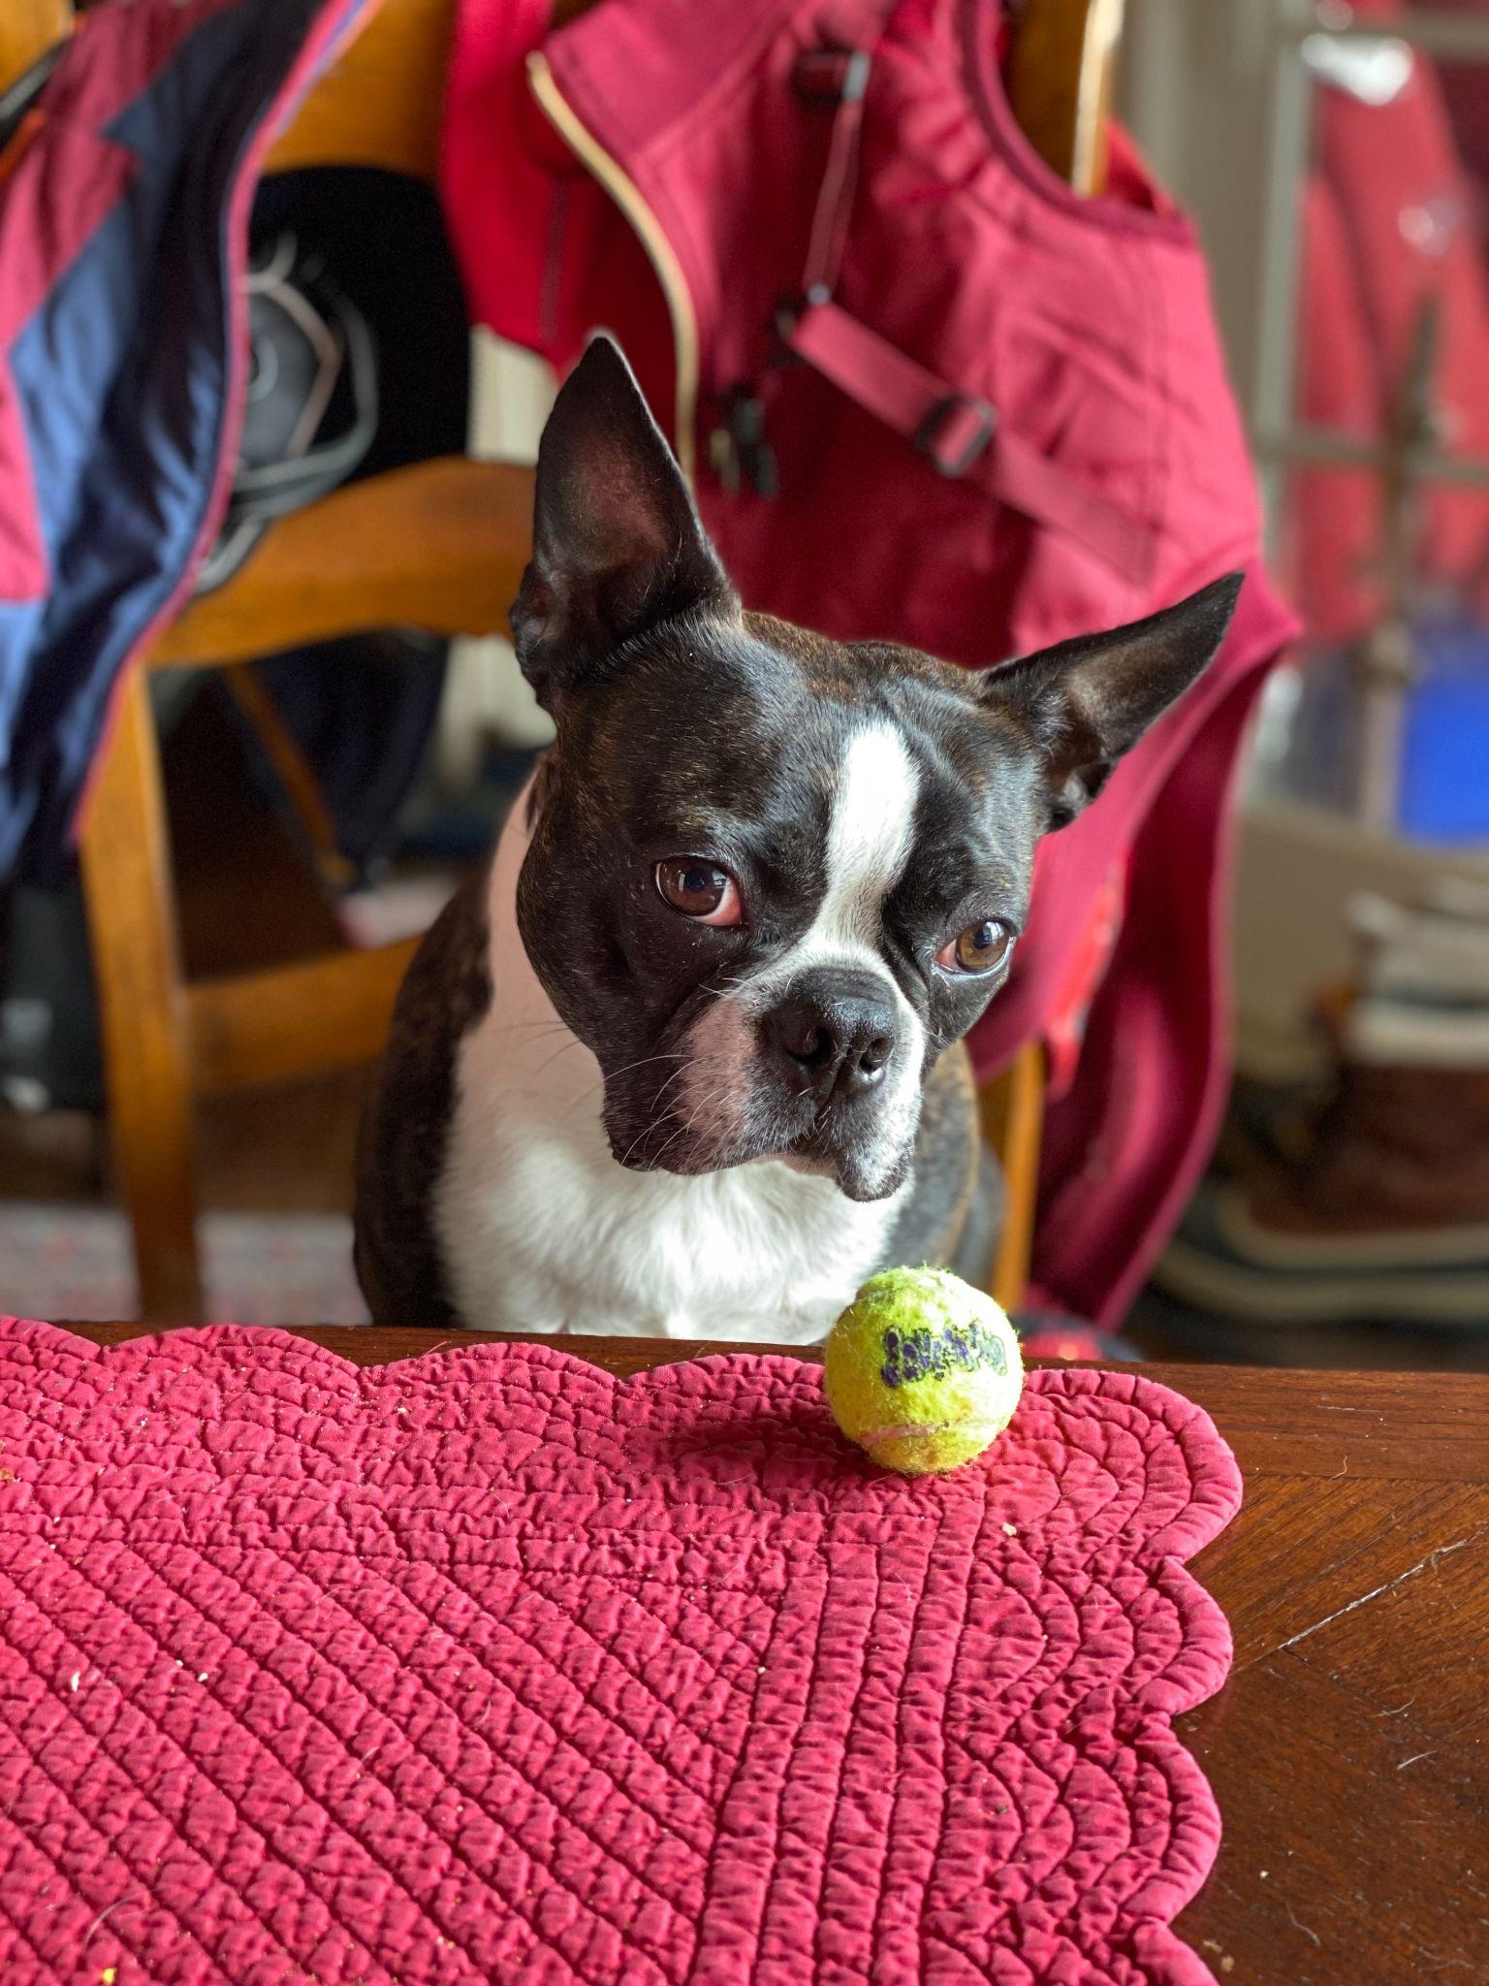Fitz

1. Fitz.jpeg
2. Boston terrier watching a tennis ball at the table.
3. Loves chasings tennis balls, chipmunks, squirrels, and birds. Often found sitting by the fire in wintertime, and in sun patches when available. He’s energetic, mischievous, and easily bored. He loves people and gets grumpy if left without a lap too long.
4. Loves barking up trees, running around on the lawn, and digging in the dirt looking for moles. He especially likes getting treats and whines when he comes inside and doesn’t get a snack.
5. **Photo Gallery – (Just write Photo Gallery)**
6. Fitz_standing_on_chair.jpeg
7. Fitz standing on a wooden chair, looking at the camera.
8. Fitz_sleeping.jpeg
9. Fitz sleeping in a fuzzy dog bed.
10. Fitz_on_the_lawn.jpeg
11. Fitz laying out on the lawn in the grass.
12. Fitz_laying_in_bed.jpeg
13. Fitz sleeping with his face buried in a plaid blanket, only his head is visible.
14. **Likes**
15. Blankets
16. Being warm
17. Barking
18. Kay Malan + Anna Vento